**Forget Me Not**: Concept Overview

A Puzzle-Platformer for PC

Target Group: Casual Gamers between 15-25 years old

**Game Summary**

Negative emotions only hold us back...that's what most people think. But that changes once they combine! In this game, the 3 major negative emotions Rage, Depression and Anxiety are on a journey through a fierce and unforgiving labyrinth of puzzles. While they would be hopelessly lost alone as they would run wild, together, they can strengthen each other and find a way to the end. So, please, forget me not…

**Game Outline**

The player navigates the 3 characters through increasingly difficult and complex levels and has to get all of them to the exit. To do this, he can use basic movement abilities (walking and jumping) and character-specific abilities. Furthermore, these abilities can be combined if two characters stand close enough together, allowing for a lot of creative thinking.

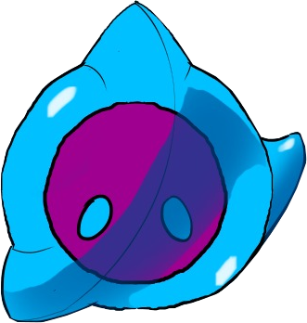

**Unique Selling Points**

* Characters can use both individual and combined abilities!
* Creative and unconventional solutions are encouraged!
* Broad abilities allow for lots of experimentation!

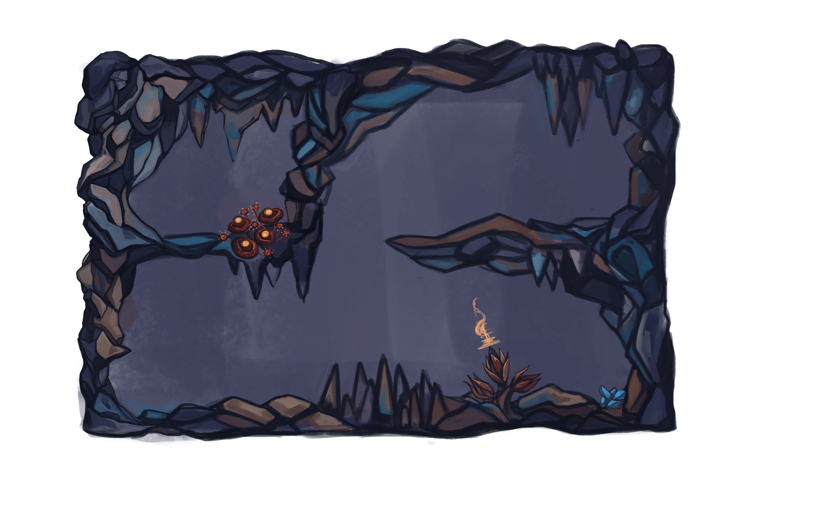

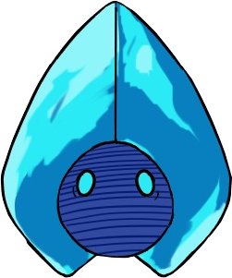



**Team info and contact**

Daniel Baracotti (Level Design/ Mechanic Design/Documentation) : [daniel.baracotti@web.de](mailto:daniel.baracotti@web.de)

Tamina Brunke (Level Design/Framework): [taminabrunke@outlook.com](mailto:taminabrunke@outlook.com)

Sebastian Gerena (Character Design/Illustrations): [belmontx21@hotmail.com](mailto:belmontx21@hotmail.com)

Alba Plaep Golfe (Project Lead/Environment Design/Illustrations): [alba.plaep@gmx.de](mailto:alba.plaep@gmx.de)

Frederyk Sperling(Programming/Sound Design): [mail@frederyk.de](mailto:mail@frederyk.de)

**Rough Production Plan**

12.12: Discord Meeting

16.12: Milestone 1

* Implement Characters
* Environment as Assets
* Working Abilities
* Good selection of Levels

22.12: Personal Meeting

23.12: Milestone 2

* Playable Levels
* Working Fused Characters
* Assets Improved

28.12: Discord Meeting

30.12: Milestone 3

* Splash/Promo Art
* Big selection of Levels
* Interface Implementation

31.12: Discord Meeting

04.01: Personal Meeting

06.01: Milestone 4

* Playable Demo
* Gameplay Video
* All Deliverables Finished

09.01: Intermediate Presentation

10.01: Discord Meeting

06.02: Final Presentation